**P5 – Describe the principles of signal theory**

**Introduction**

In this assignment, I will describe the principles of signal theory. Each of the principles, I will name the advantages and disadvantages of them. In addition, if possible, I will put up a diagram to represent the signal. The principles that I will be talking about is the following:

* Digital signalling methods;
* Representing data electronically eg bits, bytes, packet structures
* Synchronous transmission;
* Asynchronous transmission;
* Error detection and Error correction
* Bandwidth limitation;
* Bandwidth noise;
* Channel types e.g telephone, high frequency radio, microwave, satellite, bandwidth, data compression

**Analogue signals**

An analogue signal is any continuous signal, which contains time-varying quantities. These analogue signals were introduced in the mid-1990s. An example of analogue signals are speakers. This is a good example as you can increase the sound slowly and constantly. An example that analogue signals were used in the 19th century were old radios. You could continuously change the signal at any time. Three of the following could measure the analogue signal:

* Light
* Sound
* Temperature

The main advantage of using analogue signals is that they have a higher density than digital signals. They have an infinite amount of signal resolution and they differ from digital signals. Analogue signals are continuous electric signals. Analogue signals have a low cost and are portable but digital signals are not easily portable and are expensive. It can change their amplitude or frequency in response to light, sound and temperature. However, the major disadvantage of using analogue signals is that it can create a lot of noise. Whereas, analogue signals does not create as much noise as analogue signals do. Referring to Figure 1.1, it shows how analogue signals look like. It flows like a continuous wave.

[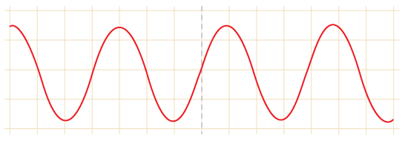](http://www.google.co.uk/url?sa=i&rct=j&q=&esrc=s&frm=1&source=images&cd=&cad=rja&uact=8&docid=6sVpW34c1psqGM&tbnid=H7IdA7nqsj8IZM:&ved=0CAYQjRw&url=http://www.bbc.co.uk/schools/gcsebitesize/design/electronics/logicrev1.shtml&ei=BygoU5TxIqPF0QW_o4DoAQ&bvm=bv.62922401,d.ZG4&psig=AFQjCNFSu-DSumdrqJdh1gNSKdF5MBr7mg&ust=1395227002801251)**Figure 1.1**

**Digital signals**

Digital signals are series of pulses that consist of two states: ON and OFF. A digital broadcast radio transmits digital signals. The waveform for digital signal switches levels from two states (0 and 1). When the digital signal is off, the number 0 represents it. When the digital signal is on, the number 1 represents it by the data. Referring to Figure 1.2, it shows us how digital signal would be data based if it would be inputted into the computer. An example of where digital signal is used is:

* PCs
* PDAs
* Mobile Phones

The main advantage of digital signals over analogue signals is that the precise signal level of the digital signal is not vital. This means that digital signals are accurate when measured. Another advantage is that it costs less electronically than analogue. Another advantage is that it carries more information per second than analogue signal. As a result, the quality is better. This is because if you increase the volume, the quality will stay the game, but analogue, it would not. However, the disadvantage of using digital signals is that it is complex, not portable and expensive.

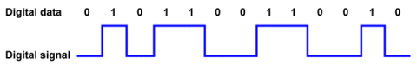**Figure 1.2**

**Comparison**

Digital signals transfer data and in the process, they do not lose the quality once reached the destination. Referring to Figure 1.3, it demonstrates the quality of both signals. Digital regenerates whereas analogue signals has a weak quality throughout the process. Digital signal can be interrupted, ON and OFF button, whereas analogue signal is a continuous signal that can travel far. It is more flexible and it can upgrade to an easier system very quickly and easily. Analogue signals are less tolerant to noise but digital signals are more tolerant to noise. **Figure 1.3**

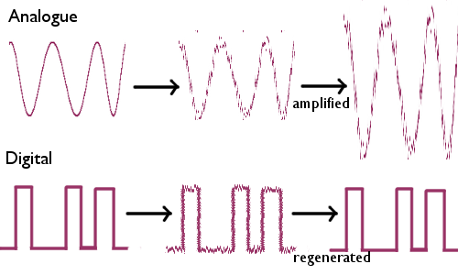

**Representing data electronically e.g. bits, bytes, packet structures**

Representing data electronically is two digits that the computer uses in order to identify and communicate with each other. The two digits are zero and one. Computers operate in binary, this means they store data and perform tasks with zeros and ones. This table below demonstrates how to convert numbers to binary, zero and one.

The main way to work it out is to convert it by using the numbers– 128, 64, 32, 16, 8, 4, 2, and 1 - to get what you want. For example, if you want 13 as a denary, you should add the ones that make 12. Therefore, 8+4. They are represented as 1 and the others are 0s. It should look like this 01100. I only used 16, 8, 4, 2, and 1 for it, as I did not need the others. However if you do want to work out 256, you would need to double 128 and carry on as normal. The ones you added to make the number you put a one and the ones you did not you put a zero.

|  |  |  |  |  |  |  |  |  |
| --- | --- | --- | --- | --- | --- | --- | --- | --- |
|  | 27= | 26 | 25 | 24 | 23 | 22 | 21 | 20 |
| Decimal | **128** | **64** | **32** | **16** | **8** | **4** | **2** | **1** |
| 72 | 0 | 1 | 0 | 0 | 1 | 0 | 0 | 0 |
| 65 | 0 | 1 | 0 | 0 | 0 | 0 | 0 | 1 |
| 85 | 0 | 1 | 0 | 1 | 0 | 1 | 0 | 0 |

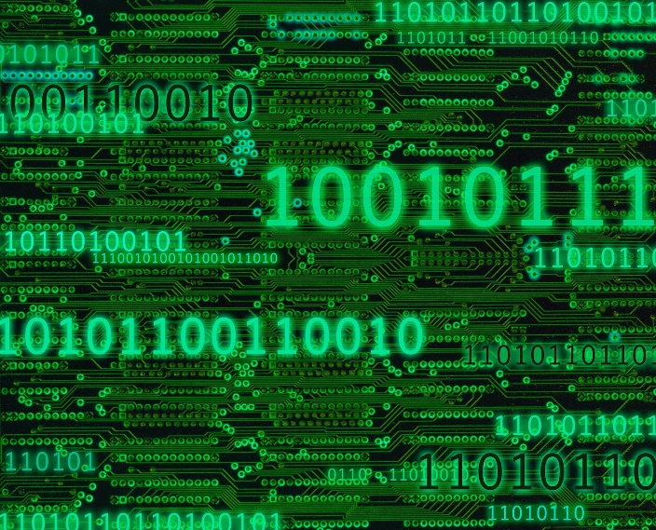

**Packet Structure**

All of the communications that is the sender and receiver is effectively to communicate. Most of the packet structure consists of **header**, **payload** and **trailer**. The header is a source of destination and other examples of packets to help it locate. The payload is the actual data being sent off. The trailer is the end bit of the packet, it marks it off.

**Advantages**

* Simple to understand ‘representing data electronically’
* Easy to communicate

**Disadvantages**

* 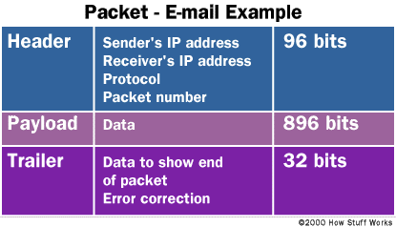Delays could happen between the communication
* Complex structure

**Synchronous transmission**

Synchronous transmission is a data type method of how the data is being sent from one place to another. This is being timed by the timing signal. Synchronous transmission sends the data in blocks and it always as a time for each of the block. Once the first block has been sent, a signal goes off to send the other block or to resend. This signal that resends or sends another one is important for the data to be successful. Once one of the blocks has been done, the clock goes off again for the other one in order for it to be complete. Asynchronous transmission is another type of data method.

**Advantage**

* Lower overhead. Overhead is if there is any excess or indirect time or memory

**Disadvantage**

* Structure is massive and slightly complex
* This makes it the hardware expensive

**Asynchronous transmission**

This method is different from synchronous transmission. This is different because each character is sending the data. They are sent ‘all of a sudden’ or altogether. Firstly, a signal is sent and then the data is sent altogether. Asynchronous transmission is commonly used through telephones. This is a perfect example, as this data cannot be sent bit by bit otherwise the other person cannot hear the person. The data needs to be sent straight away for the person to hear straight away. This is important for asynchronous transmission.

**Advantage**

* Cheap
* Simple
* Fast to set up

**Disadvantage**

* Highly likely to have a large number of overhead

**Error detection & Error correction**

Error detection and error correction, as the name suggests, is a method during the process of detecting errors whilst the process is on its way and it corrects it. Both of them works by working out if it does not match to it. Both of them have many schemes of how to detect the errors and here are some of them:

* Repetition codes
* Parity codes
* Checksums
* CRCs

Repetition works out the error by matching the 4-digit binary code. This works if it does not match. For example, if the process begins by 010101 and the other row is 011101. You can automatically see that there is something gone wrong. It has to be the same and error detection detects it automatically.

Parity code does the end bit as it detects any odd number whilst it is in process. It is a simple scheme that detects any odd numbers within it e.g. three, four or five within it. It may be a rare case, but certainly, it is important. Again, checksums detects any errors and the same with CRCs. They are both different but operate the same.

**Advantage**

* Error correction: Works in both ways, detects and corrects the error
* Error detection: Easy to locate and fix

**Disadvantage**

* Blocks of data is harder to fix instantly

**Bandwidth limitation**

Bandwidth is closely related to the speed of the computer but in a different way. Bandwidth, speed and data play an important role in bandwidth limitation. It tests how long the computer takes to download data per second. This could be referred as speed limit. Downloading data per second determines on the computer. If the internet provider is slow, it could cost the user by the speed being slow. Higher plans with the provider tends to be expensive, but much faster.

**Bandwidth noise**

Bandwidth noise can be referred to as SNR. SNR stands for signal to noise ratio. This is a daily hour process where it can affect the speed of the user’s connection. It can reduce the SNR. Noise occurs in digital and analogue signals and it can affect all types of files whilst communicating. The traditional methods can reduce the noise. This is the greatest way by the less space the spectrum occupies the less noise it would enable the data to be delivered.

**Advantage**

* Always dependent on the speed. Recommended for the speed to be high and fast, the data will be transfer it faster by downloading or uploading
* Saves time
* Less noise, the better

**Disadvantage**

* Noise can always interfere with the signal. This will enable the delivery to be slow
* Slow speed will enable to take time for downloading or uploading any files

**Channel types**

**Data compression**

**Compression techniques –** Compression techniques are used in files or image that reduce quality or does not reduce quality when used. The two types are called lossy and lossless compression.

**Lossy:**

Lossy compression is when you extract certain amount of information within a file that are not needed. Lossy compression is mostly used in likes of ‘BMP’ (Bitmap Image File). Any image loses quality depending on the compression (low, medium or high). This is used in media such as images. Another file that uses lossy is ‘JPEG’.

**Lossless:**

Lossless is a type of compression which doesn’t lose any data when reducing the amount of data. Lossless clamps all information into a 'more modest packs' or into a littler document measure by inside shorting the information. Case in point if a record size was initially 2(MB) lossless squeezing can decrease the document size into and a large portion of 1(MB) however anyway it relies on upon the document broadening on the off chance that it might be compacted effectively. Lossless packing is exceptionally valuable when using up space or attempting to spare. A great illustration of lossless layering programming might be 'WinZip'. WinZip utilizes lossless squeezing which packs things like projects features, writings, pictures, and so on which this is one of the reasons why numerous machine clients have a tendency to utilize this requisition when packing their records.

